     





Session: 2023-2024

# MINI PROJECT REPORT

### On

“DEBT MANAGEMENT”

**BACHELOR OF TECHNOLOGY**

**IN COMPUTERSCIENCE AND ENGINEERING**

**Submitted to-**

### Mr. Rajravi Kumar Ram (Department of Computer Science & Engineering)

**Submitted by-**

#### ANMOL PRATAP 2200680100060

**Section: A Semester : 3rd**

**3RD SEMESTER DEPARTMENT OF COMPUTER**

**SCIENCE AND ENGINEERING/IT/EC/EE/BT/ME**

**MEERUT INSTITUTE OF ENGINEERING AND TECHNOLOGY, MEERUT**

**DECLARATION**

We hereby declare that the project entitled **Debt Management**, which is being submitted as Mini Project in department of Computer Science and engineering to Meerut Institute of Engineering and Technology, Meerut (U.P.) is an authentic record of our genuine work done under the guidance of **Astt. Prof. Rajravi Kumar Ram** of Computer Science and Engineering, Meerut Institute of Engineering and Technology, Meerut.

Date: 27/11/2023 Anmol Pratap

Place: Meerut 2200680100060

## CERTIFICATE

This is to certify that mini project report entitled – **Debt management** submitted by **Anmol Pratap** has been carried out under the guidance of **Astt. Prof. Rajravi Kumar Ram** of Computer Science and Engineering, Meerut Institute of Engineering and Technology, Meerut. This project report is approved for Mini Project (BCC351) in 3rd semester in Computer Science and Engineering from Meerut Institute of Engineering and Technology, Meerut.

#### Internal Examiner

**Assistant Professor Raj Ravi Kumar Ram Date:**

#### Date: 27/11/2023

.

## ACKNOWLEDGEMENT

I express my sincere indebtedness towards our guide **Astt. Prof. Rajravi Kumar Ram** of Computer Science and Engineering, Meerut Institute of Engineering and Technology, Meerut for his valuable suggestion, guidance and supervision throughout the work. Without his kind patronage and guidance the project would not have taken shape. I would also like to express my gratitude and sincere regards for his kind approval of the project. Time to time counseling and advises.

I would also like to thank to our HoD Dr. (Prof.) Mukesh Rawat, Department of Computer Science and engineering, Meerut Institute of Engineering and Technology, Meerut for his expert advice and counseling from time to time.

I owe sincere thanks to all the faculty members in the department of Computer Science and engineering for their kind guidance and encouragement time to time.

Date: 27/11/2023

Anmol Pratap

2200680100060

# Table of Contents

#### Description Page No.

**Declaration i**

Certificate ii

Acknowledgement iii

Chapter 1 Introduction 1-2

* 1. Background of project
  2. Objectives of project
  3. Scope of project
  4. Significance of project
  5. Project Deliverables

#### Chapter 2 System Design 2-5

* 1. Workflow
  2. Flowchart
  3. Data Flow Diagram
  4. Working Principle
  5. Constructional Details

#### Chapter 3 Technology Bucket 5-9

* 1. Description of HTML
  2. Description of CSS
  3. Description of JSS

|  |  |  |
| --- | --- | --- |
| **Chapter 4** | **Output Screens** | **9-10** |
| **Appendices** | **Implementation Code** | **10-15** |
| **References** |  | **16** |

# Introduction

### Background of the Project

### Debt management is a financial strategy for individuals and organizations to handle debts effectively. It involves creating plans to repay debts in a manageable way. On an individual level, this includes strategies like consolidation and negotiation, while businesses balance growth needs with responsible debt levels. Debt management plans, often facilitated by credit counseling agencies, help individuals repay unsecured debts. Technology plays a role in providing tools for efficient debt tracking. The industry is subject to regulations to ensure fair practices. Addressing challenges requires financial discipline and negotiation skills.

### Objectives of the Project

1. **Financial Stability:**
   * Ensure individuals or organizations achieve and maintain financial stability by effectively managing their debts.
2. **Debt Reduction:**
   * Facilitate the reduction of overall debt burden through strategic planning and repayment strategies.
3. **Budget Management:**
   * Help individuals and businesses develop and adhere to realistic budgets to prevent future debt issues.
4. **Interest Rate Optimization:**
   * Negotiate and strategize to optimize interest rates on existing debts, reducing the overall cost of repayment.
5. **Credit Score Improvement:**
   * Assist individuals in improving their credit scores through responsible debt management practices.

### Scope of the Project

### The debt management project encompasses a comprehensive approach to address the financial challenges of both individuals and organizations. It aims to provide a range of solutions, including debt reduction, budget management, interest rate optimization, and debt consolidation. Through the integration of technology, the project seeks to streamline debt tracking and management, enhancing user experience and efficiency.

### Significance of the Project

### The debt management project holds paramount significance as it empowers individuals and organizations to navigate their financial challenges effectively. By offering tailored solutions, it not only aids in reducing debts but also improves credit scores, providing access to better financial opportunities. The project's emphasis on financial education and ethical practices contributes to building long-term financial resilience. Through the integration of technology, it enhances the efficiency of debt management processes, making financial control more accessible. Ultimately, the project plays a vital role in preventing financial distress, reducing economic burdens, and fostering a pathway to sustained financial health for its clients.

### PROJECT DELIEVERABLES

The project deliverables for a debt management initiative may include:

* + Customized plans outlining specific strategies for debt reduction, consolidation, and repayment tailored to individual or organizational financial circumstances.
  + Educational resources, such as guides, workshops, or online content, to empower clients with the knowledge and skills needed for effective debt management and financial wellness.
  + A user-friendly online platform or application for clients to track and manage their debts, offering features like budgeting tools, payment reminders, and real-time progress monitoring.

# System Design

### Workflow:

The workflow of a debt management project involves a series of interconnected steps and processes that guide the project from initiation to completion. Here's a simplified workflow for a debt management project:

* + Define the scope, objectives, and key stakeholders of the debt management project.
  + Conduct a thorough analysis to understand the financial landscape and identify potential challenges.
  + Identify and engage with key stakeholders, including clients, creditors, financial advisors, and regulatory bodies.
  + Establish clear communication channels and expectations.
  + Develop educational materials and resources to empower clients with the necessary knowledge for effective debt management.
  + Conduct workshops or training sessions to educate clients on budgeting, financial planning, and debt reduction strategies.
  + Assess the financial situation of clients, taking into account income, expenses, and existing debts.
  + Develop customized debt management plans based on the assessment, incorporating negotiation strategies with creditors.
  + Engage in negotiations with creditors to secure Favorable terms, such as reduced interest

#### 

#### Logging and Monitoring:

* System logs capture user activities for monitoring and auditing purposes.

### Flowchart:

A flowchart visually represents the steps and decision points in a process. Here's a simplified flowchart for the user interaction in an online code editor:

+

Start Program

User Login/Signup

DEBT management Interface

Access financial situation

3

End Program

Output Display

Client Enrolment

Define project scop

### Data Flow Diagram (DFD):

A Data Flow Diagram illustrates the flow of data within a system. Here's a high-level DFD for an online code editor:

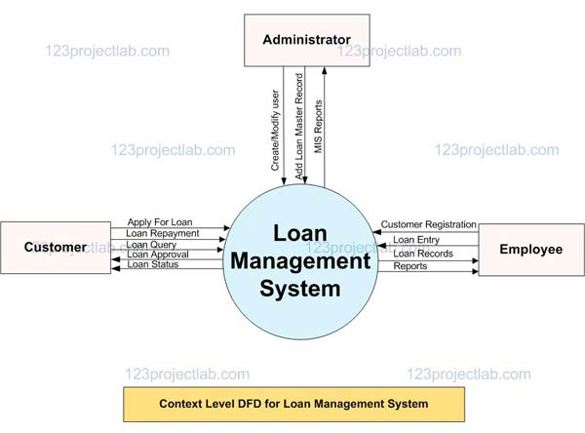

### Working Principle:

The working principle of a debt management project involves a systematic and client-centric approach to address and alleviate financial challenges. Here's an overview of the key working principles:

1. **Assessment and Analysis:**
   * **Client Evaluation:** Understand the unique financial circumstances of each client through a comprehensive assessment of their debts, income, and expenses.
   * **Stakeholder Analysis:** Identify key stakeholders and consider their interests to tailor debt management solutions effectively.
2. **Educational Empowerment:**
   * Develop and provide educational materials to empower clients with the knowledge and skills needed for effective debt management, budgeting, and financial decision-making.
3. **Customized Debt Management Plans:**
   * Create personalized debt management plans based on the assessment, considering factors such as the type and amount of debt, interest rates, and the client's financial goals.
4. **Negotiation and Communication:**
   * Engage in negotiations with creditors to secure favorable terms, such as reduced interest rates or extended payment periods, to facilitate smoother debt repayment.
5. **Technology Integration:**
   * Design and implement a user-friendly technology platform to allow clients to monitor and manage their debts efficiently. This may include features like budgeting tools, payment reminders, and progress tracking.
6. **Ongoing Support:**
   * Provide continuous support to clients throughout the debt management process, offering guidance, addressing queries, and adapting plans as needed based on changing financial circumstances.
7. **Regulatory Compliance:**
   * Implement measures to ensure compliance with relevant regulations and ethical standards, fostering transparency and fairness in all interactions.
8. **Credit Score Monitoring:**
   * Monitor and report on clients' credit scores regularly, demonstrating the positive impact of effective debt management practices on their creditworthiness.

.

**Technology Bucket**

### Description of HTML

In a typical online code editor program, HTML is used to structure the web pages, defining the layout and various elements that make up the user interface. Here's a short description of how HTML might be used in such a program:

#### Document Structure:

* The HTML document starts with the standard <!DOCTYPE html> declaration.
* The <html> element encapsulates the entire document, and the lang attribute specifies the language.
* The <head> section contains metadata like character set, viewport settings, and the title of the page.
* External stylesheets and scripts may be linked in the <head> for styling and functionality.

#### Header Section:

* The <header> element often includes a heading (e.g., <h1>) with the name of the online code editor.
* Navigation links or other header content can be included.

#### Main Content:

* The main content of the page is typically enclosed in a <main> element.
* Sections such as the code editor, collaboration features, and other main functionalities are defined within this section.

#### Code Editor Section:

* The code editor section is likely to involve a <section> or <div> with an id or class attribute for styling and scripting purposes.
* A <textarea> element is commonly used to allow users to input and edit code.
* Buttons, tabs, or other elements for code-related actions (e.g., running code or saving) are included.

#### Collaboration Section:

* A <section> or <div> is used to contain elements related to real-time collaboration.
* Elements like user avatars, cursors, or indicators for collaborative editing may be included.

#### Footer Section:

* The <footer> typically contains footer content, copyright information, or other relevant details.

#### Script Inclusion:

* The inclusion of <script> tags at the end of the document body references external JavaScript files, providing interactivity and dynamic behavior.

#### Additional Elements:

* Depending on the features of the online code editor, additional HTML elements are used for specific functionalities. For example, a file explorer might involve a <ul> or <ol> list with <li> items.

### Description of CSS

In an online code editor program, Cascading Style Sheets (CSS) plays a crucial role in determining the visual appearance and layout of the user interface. Here's a simplified, non- technical overview:

* **Global Styling:** CSS is used to define the overall look and feel of the entire application.

This includes setting the font family, background colors, and other basic design elements to create a consistent visual theme.

* **Header Styling:** Specific styles are applied to the header section, which typically includes the program's name and possibly navigation links. CSS ensures that the header has an appealing background color, text alignment, and padding for better readability.
* **Main Content Styling:** CSS is employed to structure the main content area, where the core functionalities like the code editor and collaboration features reside. This involves creating a visually pleasing layout with proper spacing and alignment.
* **Code Editor Styling:** The code editor section receives dedicated styling to enhance the user's coding experience. This might involve defining the appearance of the code input area, such as its width, height, font family, and font size. Additional styling ensures that the code editor has a clean and organized appearance.
* **Collaboration Styling:** Styles for the collaboration section focus on making the collaborative editing features visually intuitive. This could include user avatars or other indicators to show where collaborators are actively working within the code. CSS helps maintain a clear and user-friendly interface for collaborative coding.
* **Responsive Design:** CSS is used to implement responsive design principles, ensuring that the online code editor looks good and functions well across a variety of devices and screen sizes. This adaptability is achieved through media queries that adjust styling based on the device's characteristics.

### Description of Java script

JavaScript is a scripting or programming language that allows you to implement complex features on web pages . It is a cross-platform, object- oriented scripting language used to make web pages interactive

2. JavaScript is widely used for client-side scripting of web pages, but it is also used for server-side programming, game development, and mobile app development

3. JavaScript is a weakly typed language, meaning that variables do not need to be declared before they are used .

# Output Screens

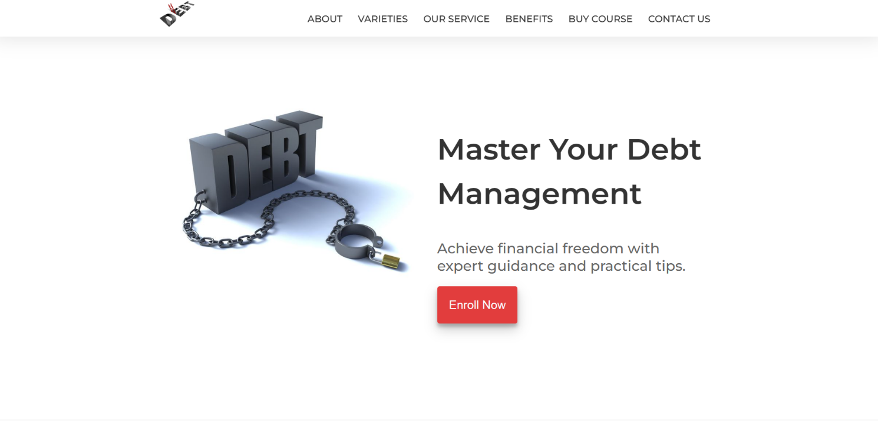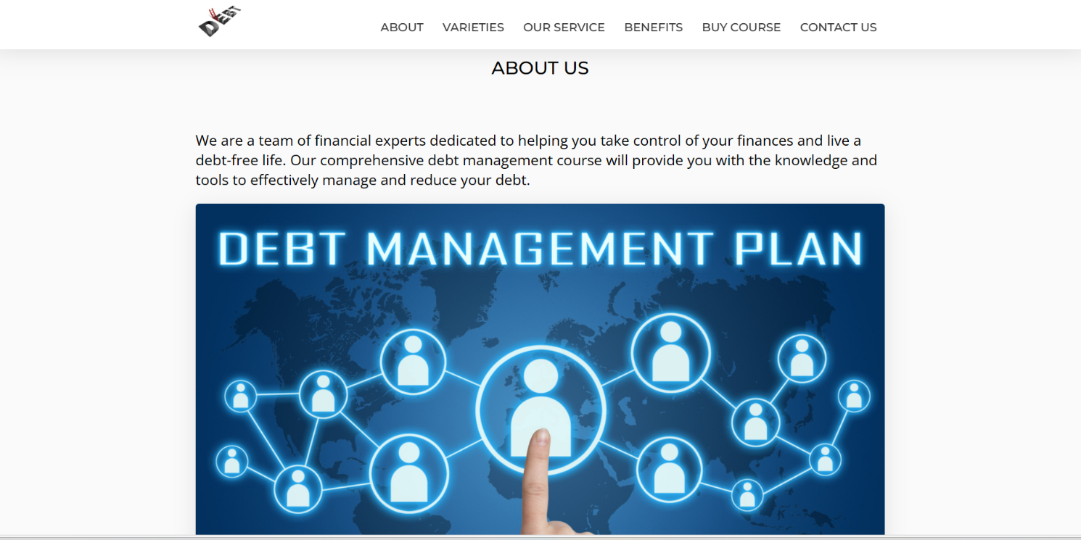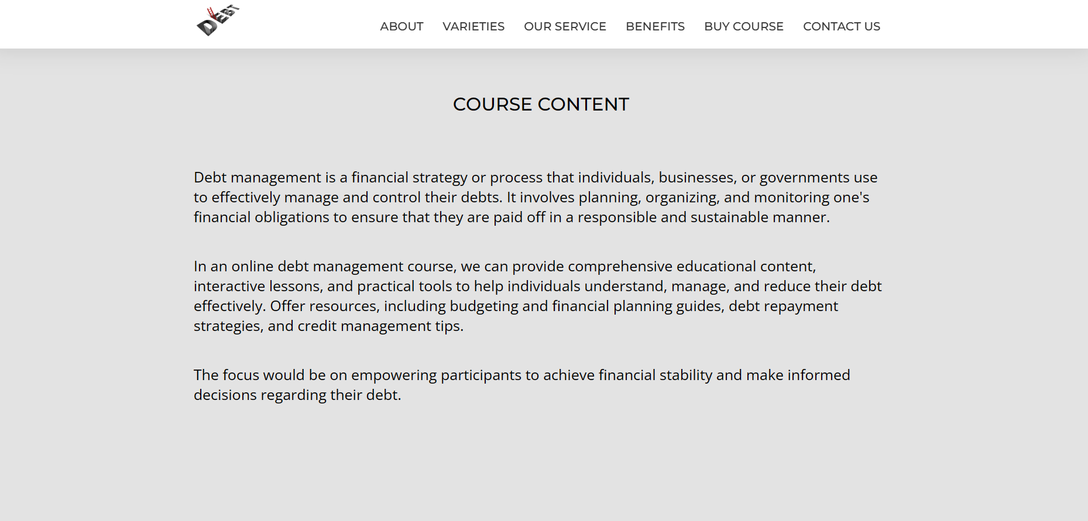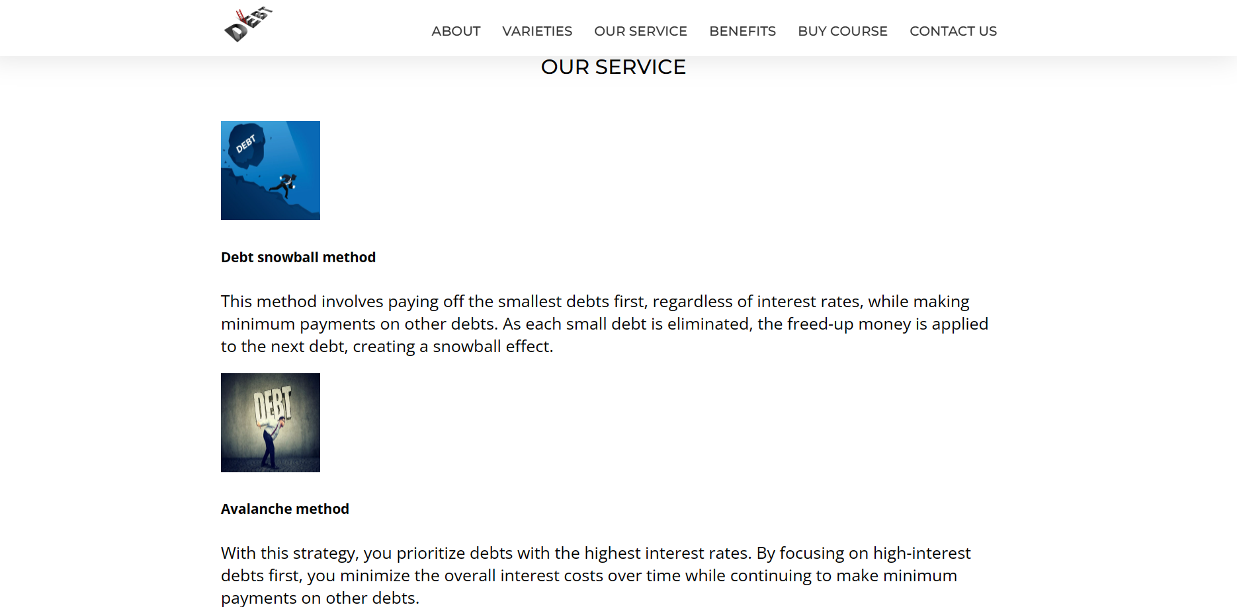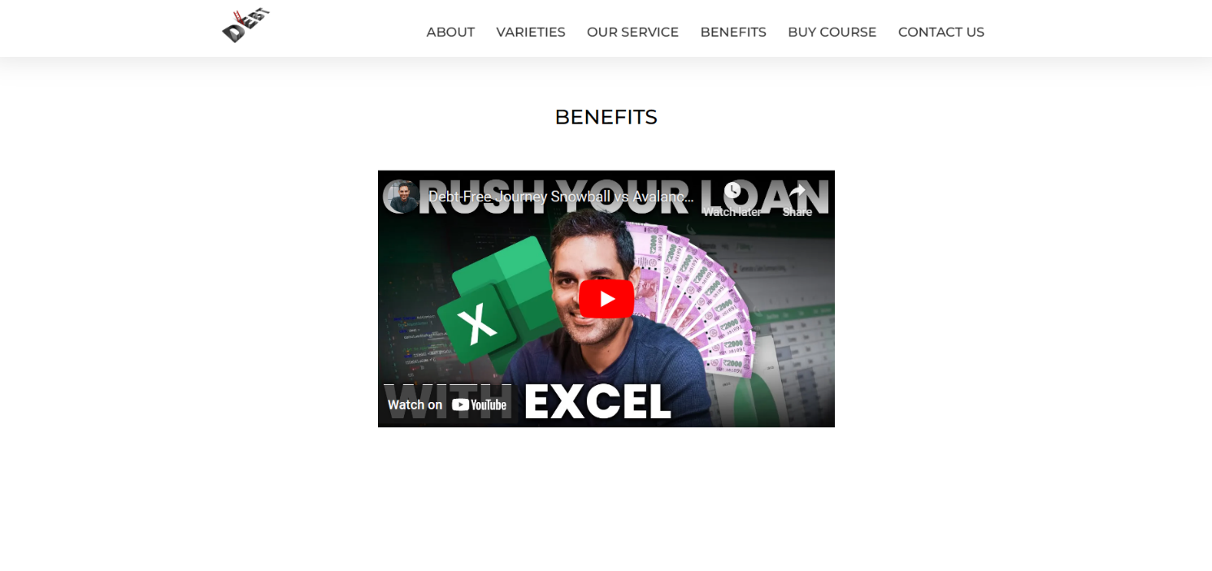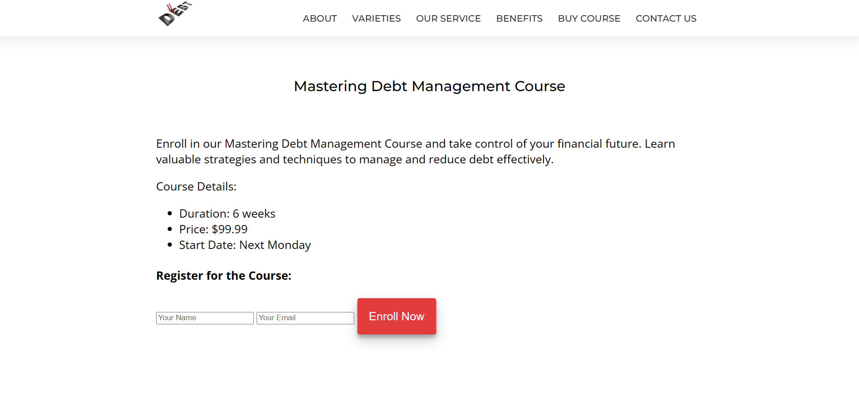

**Implementation Code**

**HTML Code** **:**

# <!DOCTYPE html>

# <html lang="en">

# <head>

# <title>Debt Management Mastery</title>

# <meta charset="UTF-8" />

# <meta name="viewport" content="width=device-width" />

# <link rel="stylesheet" href="styles.css" />

# </head>

# <body>

# <header id="header">

# <div class="header-content-div">

# <a href="#home-sec">

# <img src="2.jpg" alt="Company Logo" id="header-img" />

# </a>

# <nav id="nav-bar">

# <a href="#about" class="nav-link">ABOUT</a>

# <a href="#varieties" class="nav-link">VARIETIES</a>

# <a href="#our-service" class="nav-link">OUR SERVICE</a>

# <a href="#benefits" class="nav-link">BENEFITS</a>

# <a href="#course" class="nav-link buy-course">BUY COURSE</a>

# <a href="#contact-us" class="nav-link contact-us">CONTACT US</a>

# </nav>

# </div>

# </header>

# <main>

# <section id="home-sec" class="flexible home-sec">

# <div class="eye-grabber-img">

# <img src="image1.jpg" alt="Image of Apples" />

# </div>

# <div class="eye-grabber">

# <h1>Master Your Debt Management</h1>

# <h2>

# Achieve financial freedom with expert guidance and practical tips.

# </h2>

# <button class="btn" onclick="window.location.href = '#contact';">

# Enroll Now

# </button>

# </div>

# </section>

# <section id="about" class="sec-padding">

# <h3 class="section-heading">ABOUT US</h3>

# <div class="sec-content-div flexible">

# <p>

# We are a team of financial experts dedicated to helping you take control of your finances and live a

# debt-free life. Our comprehensive debt management course will provide you with the knowledge and

# tools to effectively manage and reduce your debt.

# </p>

# <img src="4.jpg" alt="A man plucking apples from the tree" />

# </div>

# </section>

# <section id="varieties" class="sec-padding">

# <h3 class="section-heading">COURSE CONTENT</h3>

# <div class="sec-content-div flexible">

# <p>

# Debt management is a financial strategy or process that individuals, businesses, or governments use

# to effectively manage and control their debts. It involves planning, organizing, and monitoring

# one's financial obligations to ensure that they are paid off in a responsible and sustainable

# manner.

# </p>

# <p>

# In an online debt management course, we can provide comprehensive educational content, interactive

# lessons, and practical tools to help individuals understand, manage, and reduce their debt

# effectively. Offer resources, including budgeting and financial planning guides, debt repayment

# strategies, and credit management tips.

# </p>

# <p>

# The focus would be on empowering participants to achieve financial stability and make informed

# decisions regarding their debt.

# </p>

# </div>

# </section>

# <section id="our-service" class="sec-padding">

# <h3 class="section-heading">OUR SERVICE</h3>

# <div class="sec-content-div">

# <div class="bars">

# <div class="icon-container">

# <img src="11.jpg" alt="Fresh Icon" style="width: 120px; height: 120px;" />

# </div>

# <div class="txt-container">

# <h5>Debt snowball method</h5>

# <p>This method involves paying off the smallest debts first, regardless of interest rates, while

# making minimum payments on other debts. As each small debt is eliminated, the freed-up money

# is applied to the next debt, creating a snowball effect.

# </p>

# </div>

# </div>

# <div class="bars">

# <div class="icon-container">

# <img src="1.jpg" alt="Delivered Icon" style="width: 120px; height: 120px;" />

# </div>

# <div class "txt-container">

# <h5>Avalanche method</h5>

# <p>With this strategy, you prioritize debts with the highest interest rates. By focusing on

# high-interest debts first, you minimize the overall interest costs over time while

# continuing to make minimum payments on other debts.

# </p>

# </div>

# </div>

# <div class="bars">

# <div class="icon-container">

# <img src="14.jpg" alt="Happy Icon" />

# </div>

# <div class="txt-container">

# <h5>Satisfaction Guaranteed</h5>

# <p>We are committed to your satisfaction. If you are not satisfied with our course, we offer a

# money-back guarantee.</p>

# </div>

# </div>

# </div>

# </section>

# <section id="benefits" class="sec-padding">

# <h3 class="section-heading">BENEFITS</h3>

# <div class="sec-content-div flexible">

# <iframe id="video" width="560" height="315" src="https://www.youtube.com/embed/B5nDFRFSHkc"

# frameborder="0"

# allow="accelerometer; autoplay; clipboard-write; encrypted-media; gyroscope; picture-in-picture"></iframe>

# </iframe>

# </div>

# </body>

# </html>

# <section id="course" class="sec-padding">

# <h3 class="section-heading">Mastering Debt Management Course</h3>

# <div class="sec-content-div">

# <p>Enroll in our Mastering Debt Management Course and take control of your financial future. Learn valuable

# strategies and techniques to manage and reduce debt effectively.</p>

# <p>Course Details:</p>

# <ul>

# <li>Duration: 6 weeks</li>

# <li>Price: $99.99</li>

# <li>Start Date: Next Monday</li>

# </ul>

# <h4>Register for the Course:</h4>

# <form id="course-form" action="process_course_registration.php" method="POST">

# <input type="text" name="name" placeholder="Your Name" required>

# <input type="email" name="email" placeholder="Your Email" required>

# <button type="submit" class="btn">Enroll Now</button>

# </form>

# </div>

# </section>

# <section id="course-reviews" class="sec-padding">

# <h3 class="section-heading">Course Reviews</h3>

# <div class="sec-content-div">

# <div class="review">

# <img src="a.jpg" alt="Reviewer 1" style="width: 100px; height: 100px;">

# <h4>John Doe</h4>

# <p>Excellent course! I learned valuable strategies for managing my debt effectively.</p>

# </div>

# <div class="review">

# <img src="c.jpg" alt="Reviewer 2" style="width: 100px; height: 100px;">

# <h4>Jane Smith</h4>

# <p>This course exceeded my expectations. It's a must for anyone looking to take control of their finances.

# </p>

# </div>

# <div class="review">

# <img src="b.jpg" alt="Reviewer 3" style="width: 100px; height: 100px;">

# <h4>David Johnson</h4>

# <p>I highly recommend this course to anyone struggling with debt. It's life-changing!</p>

# </div>

# </div>

# </section>

# <section id="contact-us" class="sec-padding">

# <h3 class="section-heading">Contact Us</h3>

# <div class="sec-content-div">

# <h6>If you have any questions or need assistance, please contact us:</h6>

# <p>email: acrono@gmail.com</p>

# <p>Phone1: +1-123-456-7890 </p>

# <p>Phone2: +91 9653867890 </p>

# </div>

# </section>

# References

* 1. <https://www.smashingmagazine.com/2022/01/building-web-code-editor/>
  2. <https://github.com/topics/online-code-editor>
  3. <https://www.crio.do/projects/jquery-code-editor/>
  4. <https://www.youtube.com/watch?v=dEkZfAeKK2o>
  5. <https://en.wikipedia.org/wiki/Source-code_editor>
  6. [https://code.visualstudio.com](https://code.visualstudio.com/)
  7. "Web Development and Design Foundations with HTML5" by Terry Felke-Morris
  8. "Eloquent JavaScript" by Marijn Haverbeke